Dear Guests,
​
What follows are Instructions for locating THE SECRET DOORWAY to Musée Patamécanique.

Please Note: We generally collect Admission and Guest Agreement Forms before our tours depart - but if you're entering the museum through the Secret Doorway we must collect these materials via "The Honor System". All tours are CASH ONLY. Please deposit your $20.00 per person admission and guest agreement forms in the black envelope placed on the shelf on your left as you enter the museum.
​
The good news is that you will no longer need to recite your tasty letters!
​
It is extremely important that you begin following these instructions at your pre arranged tour departure time. You MUST be prompt. If you arrive too early the doorway will be locked. If you come too late, the doorway will vanish! The doorway is a 5-minute walk (or a 1 minute drive with plenty of parking) from all of our regular departure locations - so there is no need to rush if this is a last minute change in plans due to weather. You will be outside, but only briefly - so bring an umbrella if you can!

Step 1, Arrive at the municipal parking lot ACROSS THE STREET from the Bristol Historical Society at your scheduled departure time. You can usually find a parking spot here without any trouble. DO NOT come early.

The address for the Historical Society is:
48 Court Street Bristol, RI 02809.

Here is a link to a Google Map of this location.
https://www.google.com/maps/place/48+Court+St,+Bristol,+RI+02809/@41.6695681,-71.2772919,17z/data=!3m1!4b1!4m5!3m4!1s0x89e454652ebc791f:0x78e1f622722787ca!8m2!3d41.6695681!4d-71.2751032

The Historical Society offices occupy an old jail-house. This building is made of stone with an ornate wooden awning over the front door.
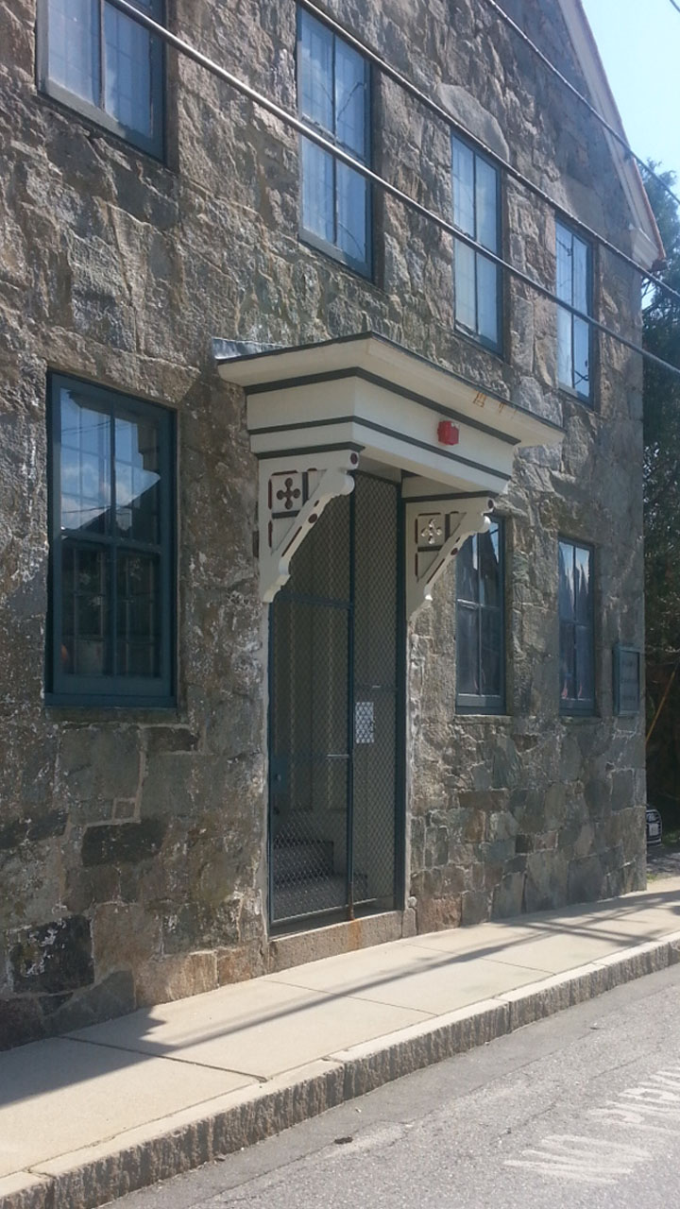

The old jail-house is pictured in the photo above.

You're going to the PARKING LOT ACROSS THE STREET - pictured in the photo below.
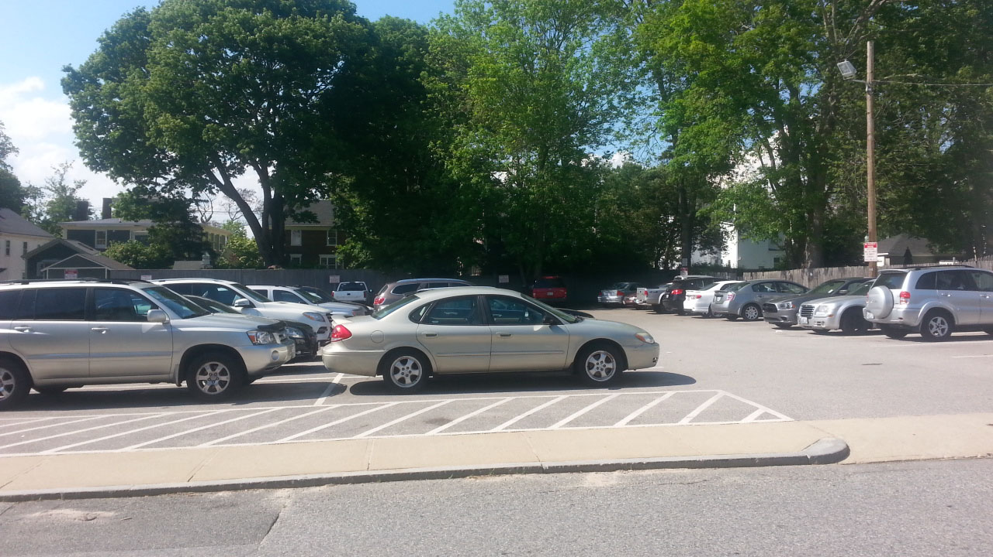

Step 2, Exit your vehicle (if you're driving) and begin walking toward the North West corner of the Parking lot – this is the far corner where two wooden fences meet.
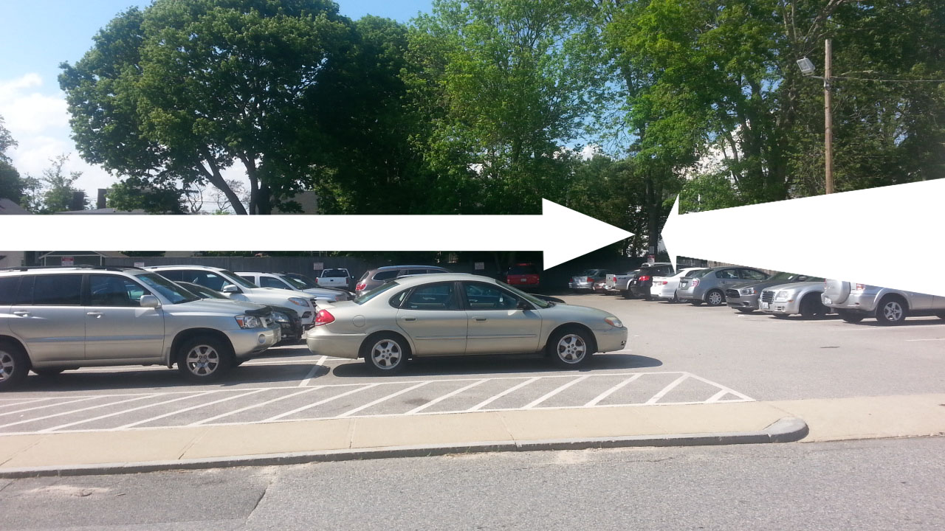

There is a tree growing in the corner. This tree has 2 metal sighs posted on it, one reads; ”NO LITTERING, KEEP BRISTOL CLEAN” and a larger one below it says “NO OVERNIGHT PARKING, VIOLATORS WILL BE TOWED AT OWNERS EXPENSE”.

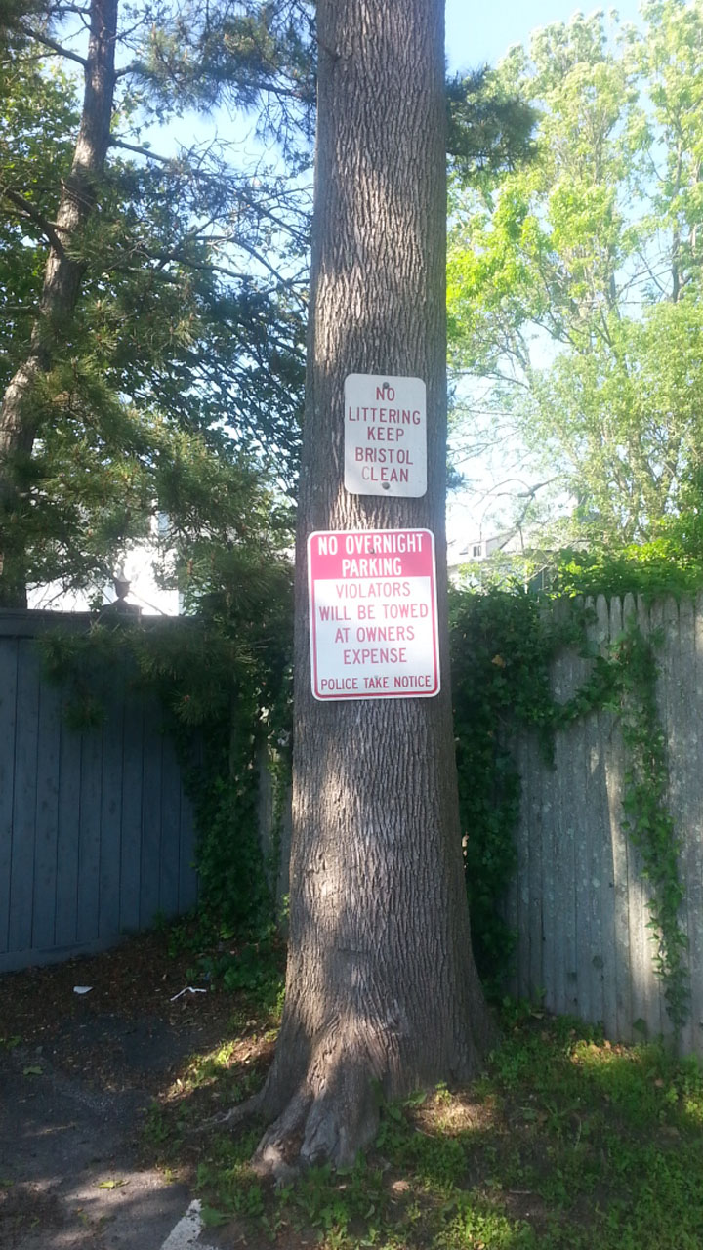
​
Go to this unfriendly tree. We call it the "Secret Unfriendly Tree".

Step 3, When you get to the Secret Unfriendly Tree – look around. Make sure nobody is watching you.

Step 4, When you're sure that nobody is watching, discreetly walk around to the BACK of the Secret Unfriendly Tree. Here you will find THE SECRET DOORWAY. Open the doorway and read the instructions posted very carefully before taking another step. These hidden passages will take you directly to Musée Patamécanique in less than 5 minutes.
​

